Name:_______________________________________

Assignment 6: Shapes and Kaleidescope

1. Make a new project called Assignment 6: Drawings in Snap
2. Use the following blocks to draw a square - you will want to change the number of steps and the number of degrees:

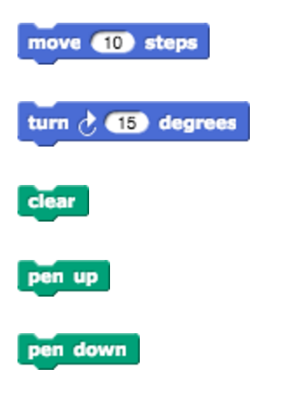

1. Use 3 scripts to draw a different shape in a different color in a different place on the stage when 3 different keys are pressed. For example:
   1. When the spacebar is pressed, draw a red square in the middle
   2. When the “a” key is pressed, draw a blue square on the left
   3. When the “b” key is pressed, draw a star on the top

Make sure that each script includes clear, pen up, and pen down, or else the stage will get very messy!

1. Save the project
2. Check out this Snap program for a while: <http://tinyurl.com/SNAPKaleidoDraw>. Try pressing “d” and “u” while moving the mouse around the stage area. Make sure you understand what each script is doing.
3. Create a new project called Assignment 6: Kaleidescope in Snap
4. Use what you learned from the previous program to create a kaleidoscope in Snap - ask the instructor to show you what it should look like. 4 different colored sprites should mirror your mouse on 4 sides of the stage.
5. Save the project